**JOB PORTAL**

Contents

Project Description: 1

Introduction to the Job Portal web application 1

Purpose and features of the portal for job seekers and employers 1

What you'll learn: 2

Overview of the topics and skills covered in the project 2

Use Case: 3

System Requirements: 3

Application Dependencies: 3

Spring Boot: 4

Project Structure 6

Configuration MongoDB: 7

Important Notes: 9

Usage Of Users in Job Portal 10

**Features and Functionality:** 11

Candidate Dashboard: 11

Save Candidate Resume: 11

Job Listing and Job View: 12

Company Details: 13

Search Jobs by Title and Location: 14

Company/Recruiter - Posting a Job and downloading profile: 15

Company/Recruiter – Sending a Mail to Candidate: 16

USAGE OF LOGIN AND REGISTRATION 17

Roles: 18

Authentication and Authorization: 19

User Registration: 19

Login: 20

Dashboard Views: 21

Candidate Dashboard: 21

Recruiter Dashboard: 21

Access Control: 22

FILE HANDLING 23

File Download (Company/Recruiter): 24

USING BCRYPTPASSWORD ENCODING TO SECURE PASSWORD 25

How to use it: 25

TESTING EXECUTION 26

Installation and Setup Instructions 26

Running the Application Locally: 26

Configuration and Environment Setup: 27

Configuration of SMTP(Simple Mail Transfer Protocol) 27

Configuration of File Upload and Download 28

USER REGISTRATION 29

CANDIDATE ROLE BASE LOGIN 29

you can also view your applied jobs from your dashboard 31

RECRUITER ROLE BASE LOGIN 31

A RECRUITER CAN ALSO EXPLORE CANDIDATES BASED ON THERE PROFILE IT HAS CANDIDATE LISTING PAGE TOO 34

Error Solving Section 37

# Project Description:

## Introduction to the Job Portal web application

Welcome to our Job Portal! Our job portal is a comprehensive online platform designed to connect job seekers with employers and facilitate the recruitment process. Its main purpose is to serve as a bridge between job seekers and employers, helping both parties find the best match for their needs.

## Purpose and features of the portal for job seekers and employers

**For Job Seekers**:

Our portal provides a user-friendly interface where job seekers can create profiles, upload resumes, and search for job opportunities that align with their skills, qualifications, and preferences. They can explore a wide range of job listings from various industries, locations, and experience levels. Our advanced search and filtering options enable job seekers to pinpoint the most relevant opportunities quickly.

Additionally, job seekers can set up job alerts to receive notifications about newly posted positions that match their criteria. They can also access resources such as interview tips, career advice, and industry insights to enhance their job search and professional development.

**For Employers**:

Employers can benefit from our job portal by reaching a vast pool of potential candidates actively seeking new opportunities. They can post job openings, review applications, and manage the recruitment process efficiently through the portal's intuitive employer dashboard.

Our portal allows employers to screen applicants' profiles and resumes, communicate directly with candidates, and schedule interviews.

**Key Features:**

1. Job Search and Matching: Advanced search and matching algorithms help job seekers find relevant positions and employers to discover suitable candidates.

2. Profile Creation and Management: Job seekers can create and maintain their profiles, showcasing their skills and experience, while employers can manage job listings and company profiles.

3. Communication Tools: Integrated messaging systems enable direct communication between job seekers and employers, facilitating seamless interaction.

4. Job Alerts: Job seekers can set up personalized job alerts, receiving notifications about new job openings that match their preferences.

Our job portal strives to be a central hub for job seekers and employers alike, empowering job seekers to find meaningful employment and assisting employers in identifying top talent to fill their job vacancies efficiently.

# What you'll learn:

## Overview of the topics and skills covered in the project

1. **Spring Boot Framework**: You will learn how to build a web application using the Spring Boot framework, which simplifies the process of developing Java-based web applications.
2. **Thymeleaf Templating Engine**: Thymeleaf is a popular templating engine for Java-based web applications. You will learn how to use Thymeleaf to create dynamic and interactive web pages.
3. **MongoDB Database Integration**: You will learn how to integrate MongoDB, a NoSQL database, with the Spring Boot application to store and manage data related to users, companies, job listings, and candidate applications.
4. **Model-View-Controller (MVC) Architecture**: You will understand the MVC architectural pattern and how it is implemented in the Spring Boot application to separate concerns and maintain code organization.
5. **User Authentication and Authorization**: You will learn how to implement user authentication and authorization to restrict access to certain functionalities based on user roles (candidates, recruiters, administrators).
6. **File Upload and Download**: You will learn how to implement file upload and download functionalities to allow candidates to upload their resumes and recruiters to download candidate resumes.
7. **Data Validation and Error Handling**: You will learn how to validate user input and handle errors gracefully to provide a smooth user experience.
8. **Fetching and Displaying Data**: You will understand how to fetch data from the backend (MongoDB) and display it in a user-friendly format on the frontend using Thymeleaf templates.
9. **RESTful API Design:** You will learn how to design and implement RESTful APIs to support data retrieval and manipulation operations.
10. **Frontend Development**: While this project primarily focuses on the backend using Spring Boot, you will also gain exposure to frontend development using HTML, CSS, and the Metro UI framework for styling.
11. **Session Management**: You will learn about managing user sessions using HTTP sessions or other state management techniques to maintain user data and preferences across requests.

# Use Case:

The job portal offers various features for candidates, companies/recruiters, and administrators. Candidates can explore available job listings, view job details, apply for jobs, and track their applications. They also have the option to update their profile information. Companies/recruiters can post job openings, view applicants, and download submitted resumes. Administrators have the authority to manage user accounts, job listings, and generate insightful reports. General use cases include user authentication, job search, error handling, user registration, session management, file upload/download, and role-based access control. These functionalities collectively enhance the user experience and ensure smooth operations within the job portal.

# System Requirements:

* Operating System: The application should be compatible with major operating systems like Windows, macOS, and Linux.
* Java Runtime Environment (JRE): The system should have Java JRE installed to run the Java-based application.
* Web Browser: For accessing the web-based portal, modern web browsers such as Google Chrome, Mozilla Firefox, or Microsoft Edge should be supported.
* Internet Connection: An active internet connection is required to access the web-based portal and interact with the server.

# Application Dependencies:

* Spring Boot: The application is developed using the Spring Boot framework, which simplifies the development process and provides features like dependency injection and MVC architecture.
* Thymeleaf: Thymeleaf is used as the templating engine to create dynamic HTML pages for the web-based portal.
* MongoDB: The application utilizes MongoDB as the NoSQL database to store candidate details, company information, job listings, resumes, and user data.
* Spring Data MongoDB: This dependency is used to interact with the MongoDB database using Spring Data repositories and operations.
* Spring Security: Spring Security is used for user authentication, authorization, and role-based access control to secure the application.
* Bootstrap: The front-end of the web-based portal is designed using Bootstrap CSS framework, ensuring a responsive and visually appealing user interface.

# Spring Boot:

**What is Spring Boot?**

Spring Boot provides a good platform for Java developers to develop a stand-alone and production-grade spring application that you can **just run**. You can get started with minimum configurations without the need for an entire Spring configuration setup.

**Why Spring Boot?**

You can choose Spring Boot because of the features and benefits it offers as given here −

* It provides a flexible way to configure Java Beans, XML configurations, and Database Transactions.
* It provides a powerful batch processing and manages REST endpoints.
* In Spring Boot, everything is auto configured; no manual configurations are needed.
* It offers annotation-based spring application
* Eases dependency management
* It includes Embedded Servlet Container

**Let’s Begin Downloading Dependencies and Application we Require For this Project:**

1. Java Development Kit (JDK): If you don't have Java installed on your system, download and install the latest version of the Java Development Kit (JDK) from the official Oracle website or OpenJDK website. Ensure you have JDK 8 or higher.
   * Oracle JDK: <https://www.oracle.com/java/technologies/javase-downloads.html>
2. Integrated Development Environment (IDE): Choose your preferred IDE to work with the project. Two popular options are IntelliJ IDEA and Eclipse. Download and install your preferred IDE.
   * IntelliJ IDEA: <https://www.jetbrains.com/idea/download/>

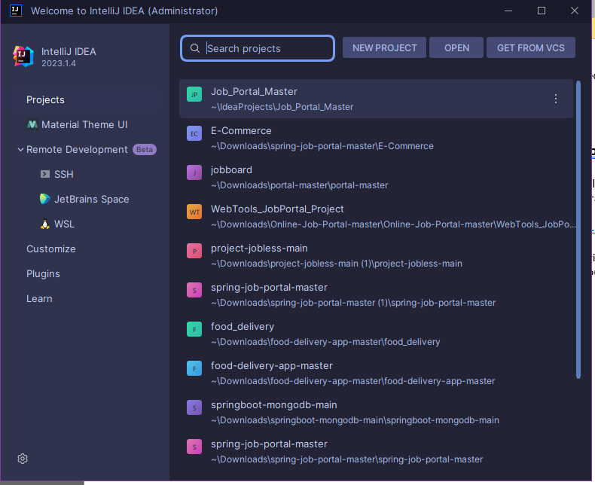

1. MongoDB: Install MongoDB on your system to set up the database for the project. Download the appropriate version for your operating system from the MongoDB website.
   * MongoDB: <https://www.mongodb.com/try/download/community>

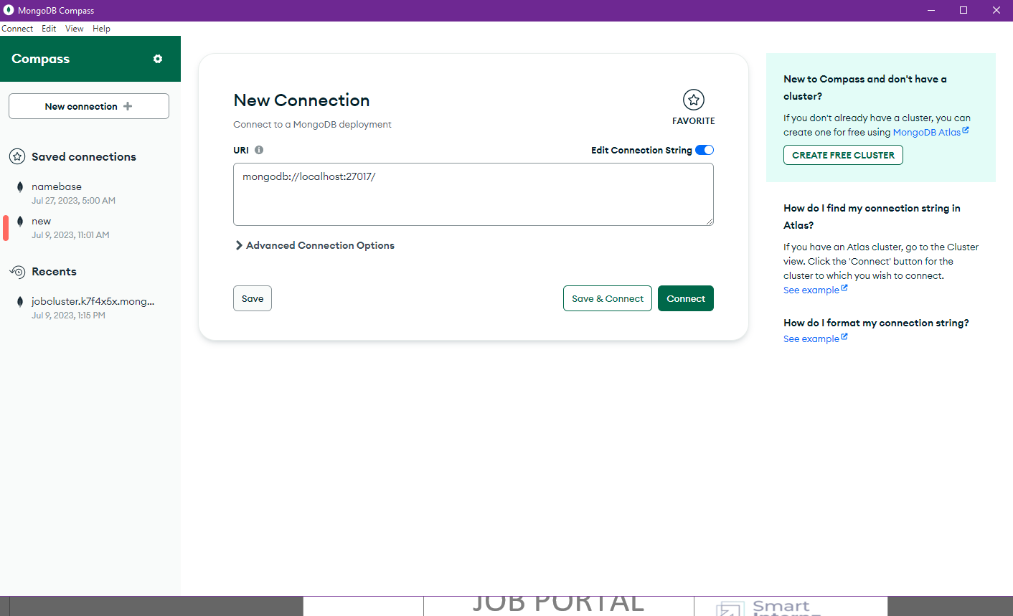

1. Project Setup - Spring Initializer: Use Spring Initializer to generate the initial project structure with the necessary dependencies. Visit the Spring Initializer website:
   * Spring Initializer: <https://start.spring.io/>

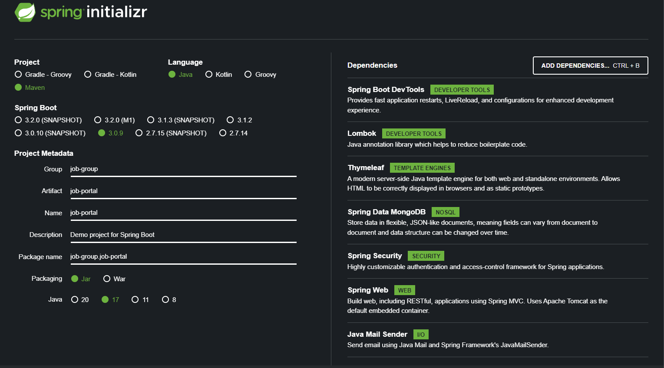

After configuring, click "Generate" to download the project zip file.

# Project Structure

**Project Structure:** Organize your project into packages. Create packages for entities, repositories, services, controllers, and configurations.

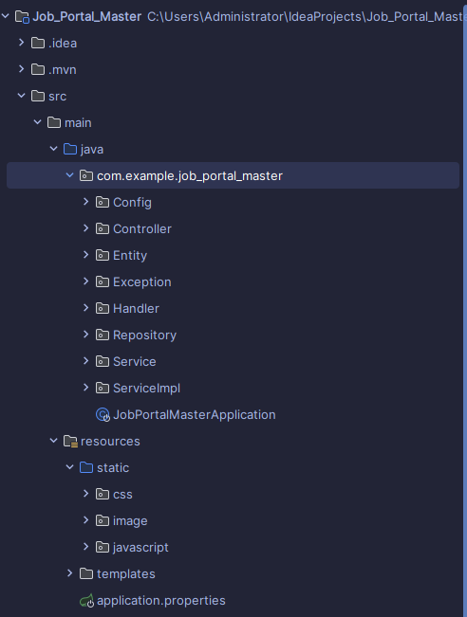

* It is the most important to sort your packages in spring boot so main program can identify it during compilation
* sorting out your package is must for program to run
* Use `@SpringBootApplication` in the main class to mark it as the entry point of the Spring Boot application.
* Employ `@ComponentScan(basePackages = "...")` to specify the base packages for component scanning, allowing Spring to discover and register beans in those packages.
* Group related classes using annotations like `@Controller`, `@Service`, and `@Repository` to differentiate between web controllers, services, and data access components.
* Leverage `@Configuration` for package-level configurations, ensuring specific settings are confined to relevant packages.

# Configuration MongoDB:

1. Connecting MongoDB Atlas to Project Via MongoDB Compass and create User profile
2. Create a MongoDB Atlas Cluster, whitelist your IP, and create a database user.

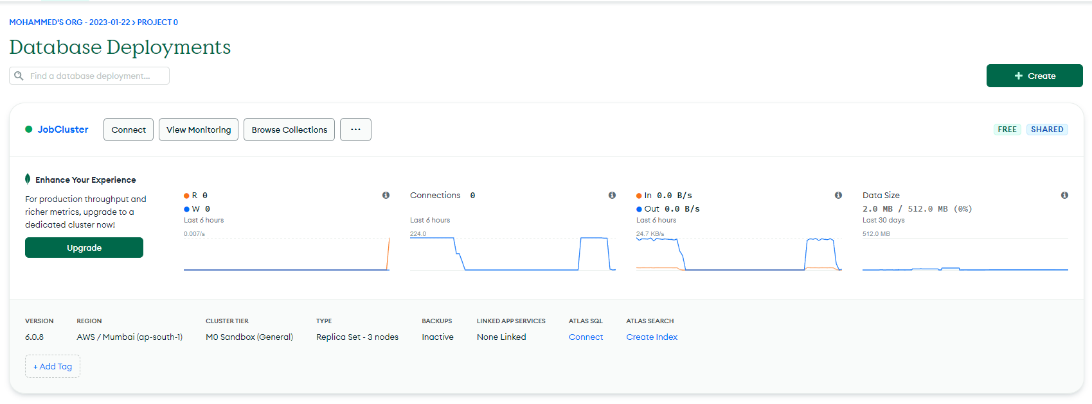

1. Choose java as Driver and Choose Version of Driver which required Copy the connection string from MongoDB Atlas, open MongoDB Compass, and paste the connection string to connect.

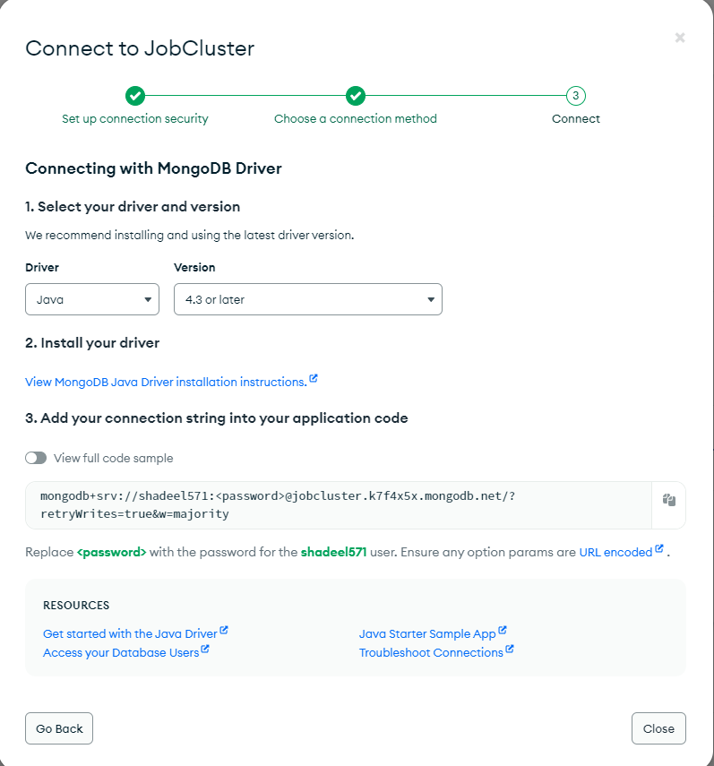

1. Connect to MongoDB Atlas via MongoDB Compass and test the connection.

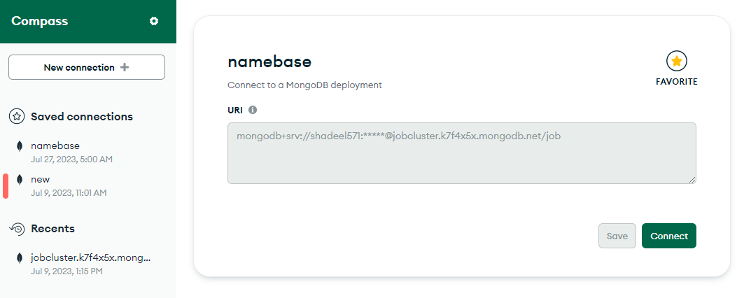

1. In your Spring Boot application's `application.properties`, add the connection string and database name.

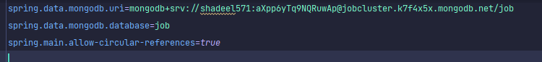

1. For User name and password your username would be your profile name and for password use password generated from when you create your database use that password and username.
2. Save changes, and your Spring Boot project is now connected to MongoDB Atlas.

## Important Notes:

* Add your database name in the line of url so you could connect database and you don’t to implement username and password separately.
* Use MongoDB Configuration syntax to connect Spring Boot to MongoDB
* Either you can use MongoDB Atlas or MongoDB Compass its your choice

# Usage Of Users in Job Portal

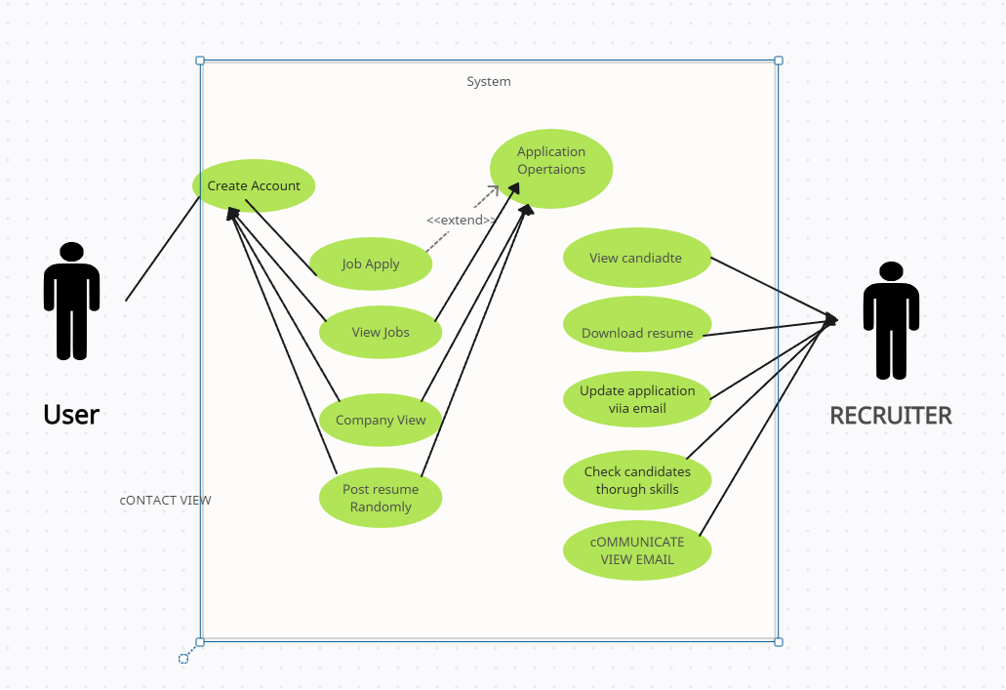

# **Features and Functionality:**

## Candidate Dashboard:

* + Candidates can view a list of applied companies and their respective job titles and statuses.
  + The dashboard displays the details of jobs for which the candidate has applied.
  + The list of applied companies and jobs is fetched from the backend and displayed in a card format
  + Using thymleaf

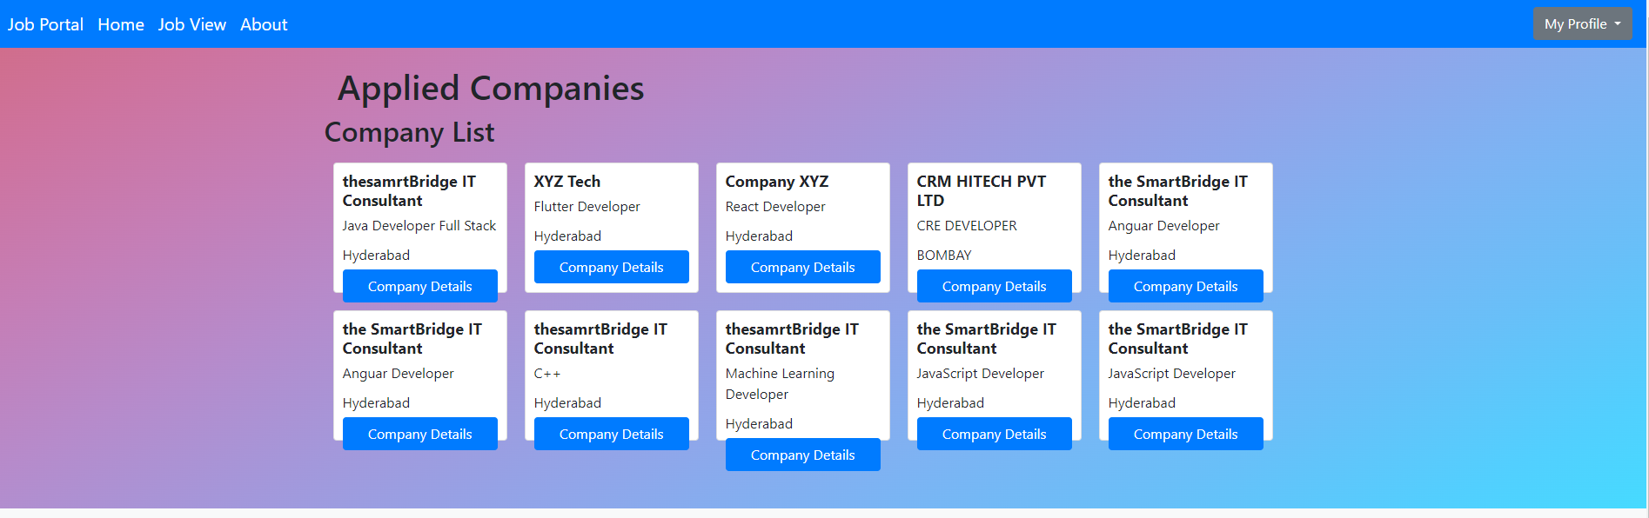

## Save Candidate Resume:

* + Candidates can upload and save their resume in the system.
  + The uploaded resume is processed and saved to the backend using the **saveResume** method in the **CandidateController**.
  + The uploaded file is associated with the candidate's profile for future reference.

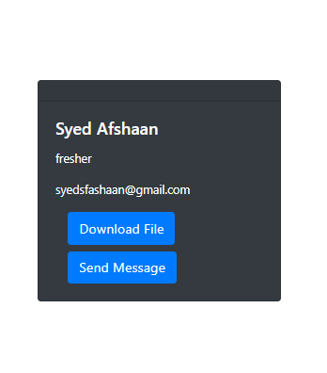

## Job Listing and Job View:

* + Candidates can view a list of available job openings from various companies.
  + The list of job openings is fetched from the backend and displayed on the candidate's dashboard.
  + Candidates can click on a job to view its details, including the job title, description, and location.
  + The job details are fetched from the backend and displayed in a separate view using the **viewJob** method in the **CandidateController**.

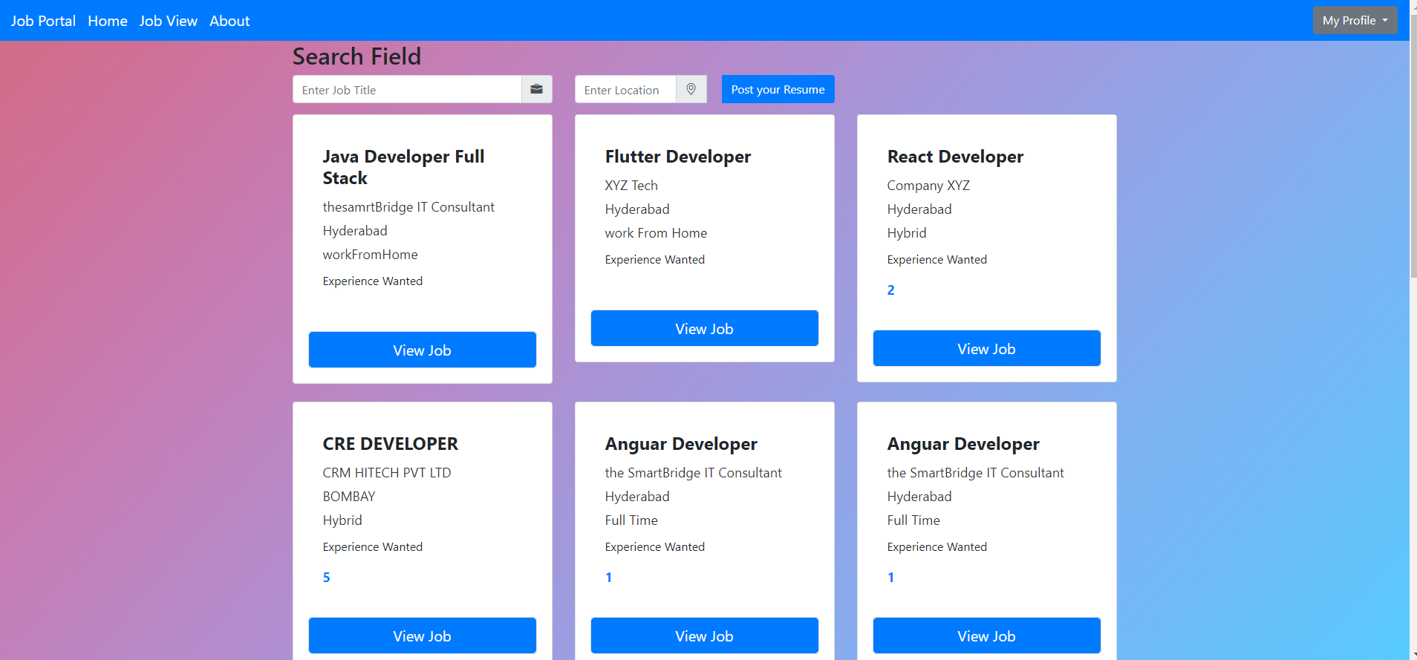

## Company Details:

* + Candidates can view a list of companies that have posted job openings.
  + The list of companies is fetched from the backend and displayed on the candidate's dashboard.
  + Candidates can click on a company to view its details, including the company name and job titles offered.
  + The company details are fetched from the backend and displayed in a separate view using the **companyList** method in the **CandidateController**.

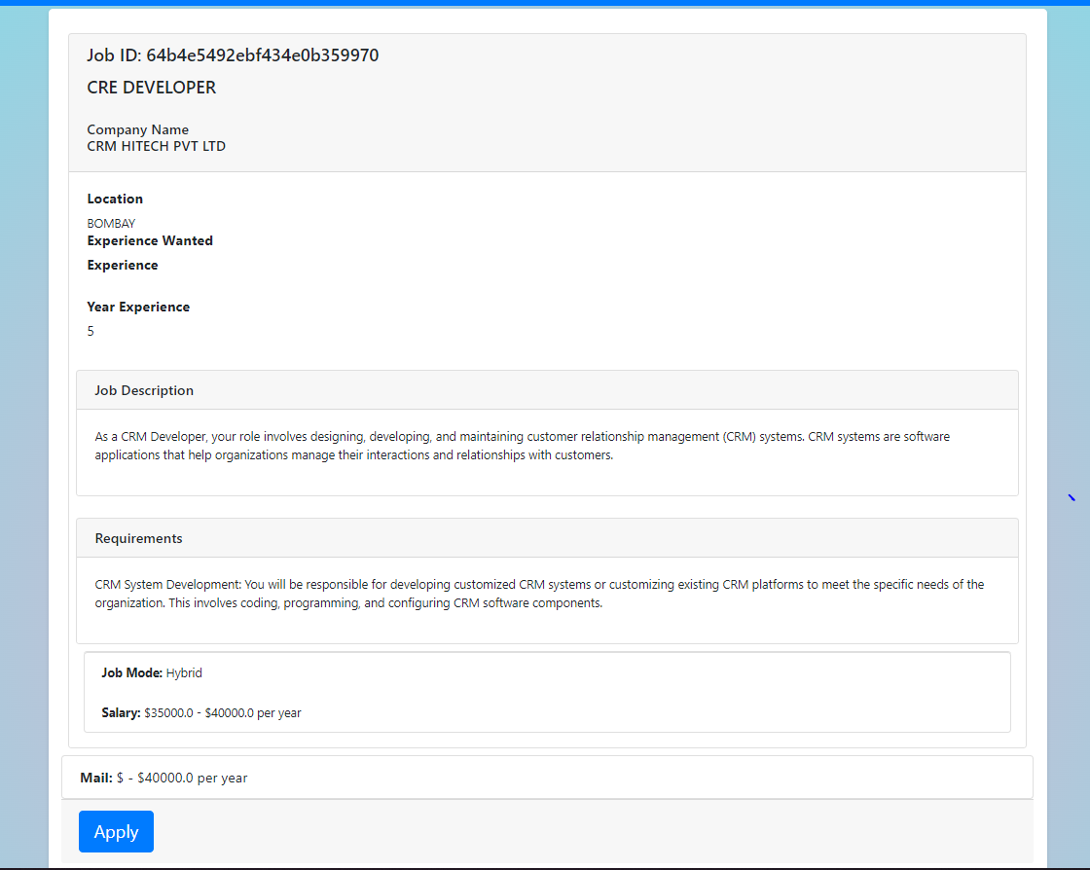

## Search Jobs by Title and Location:

* + Candidates can search for job openings based on job titles and/or locations.
  + The search query is sent to the backend, and the relevant job listings are retrieved and displayed using the **searchCompanyDetails** and **searchLocation** methods in the **CandidateController**.

**Search Company Details**

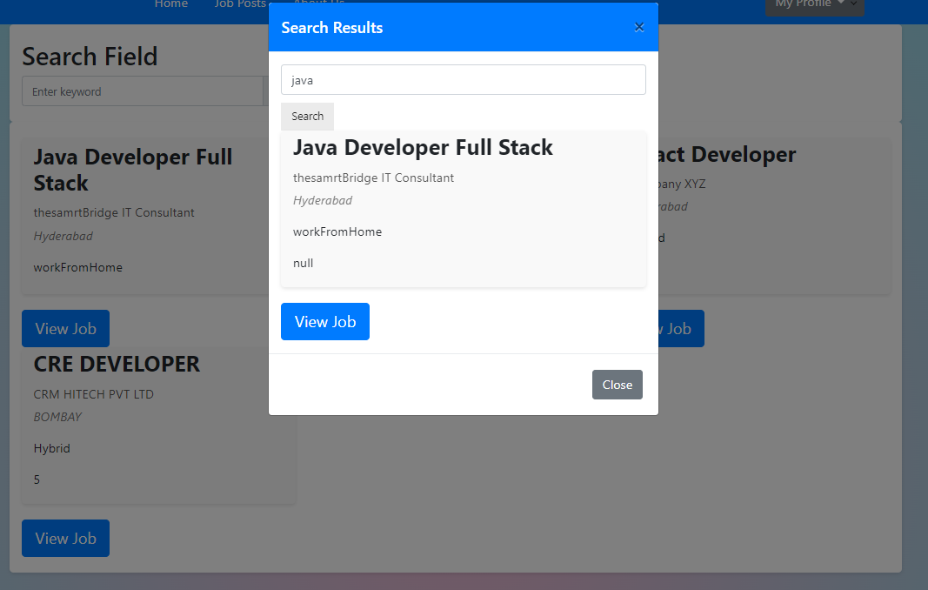

**Search Location**

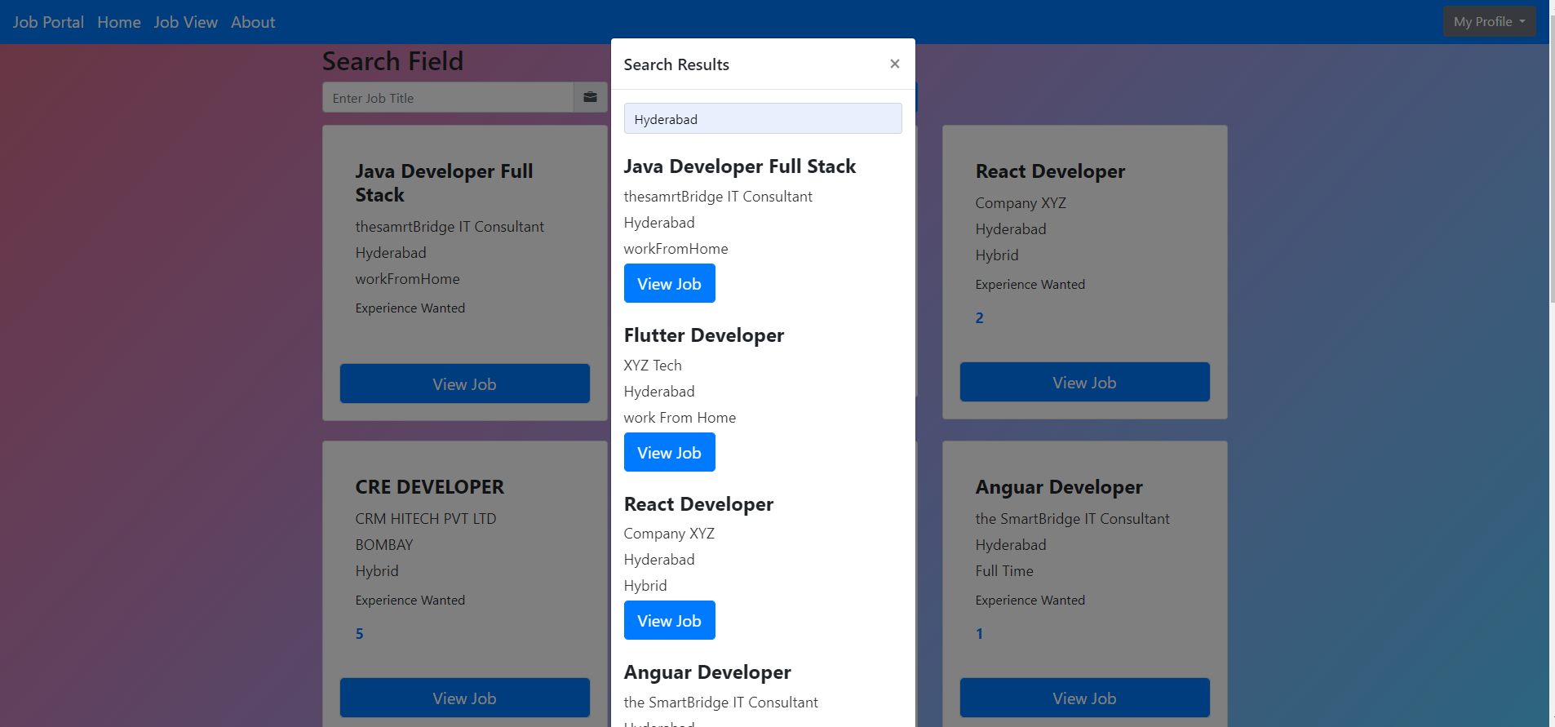

## Company/Recruiter - Posting a Job and downloading profile:

* A recruiter can post a job by filling up a form and if some candidate applied for that job recruiter can view his profile and download his/her profile in PDF format

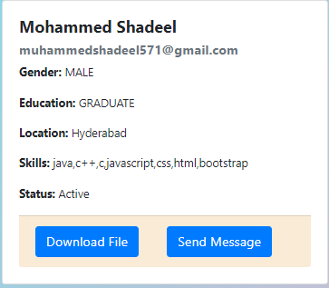

**MongoDB Database Data**

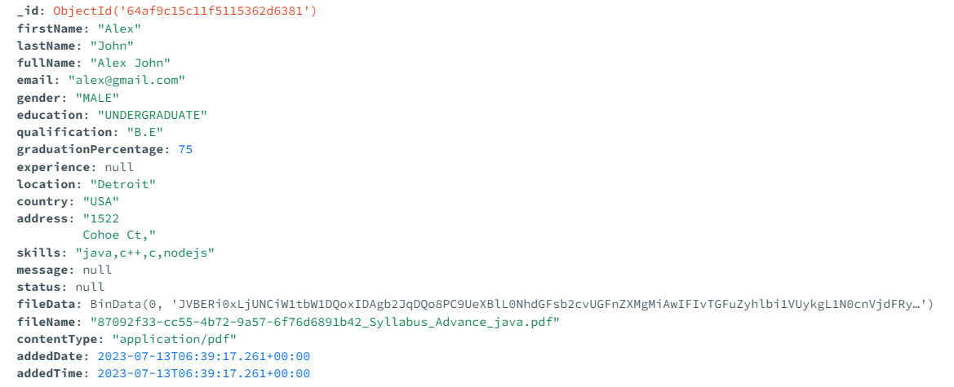

# Company/Recruiter – Sending a Mail to Candidate:

* A recruiter can send a mail to candidate and in that mail recruiter can choose if the candidate is selected or not

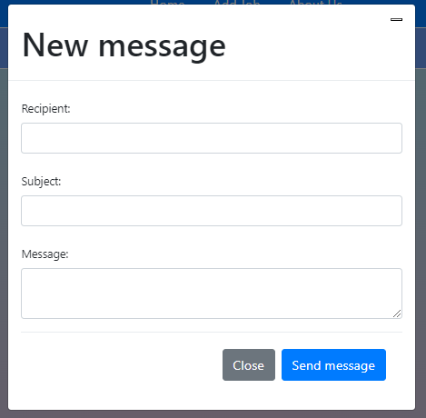

**Email Send by Recruiter**

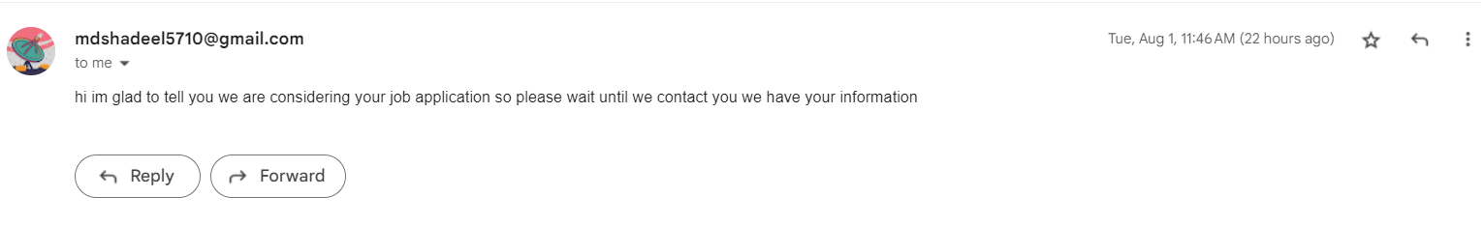

# USAGE OF LOGIN AND REGISTRATION

**(ROLE BASED)**

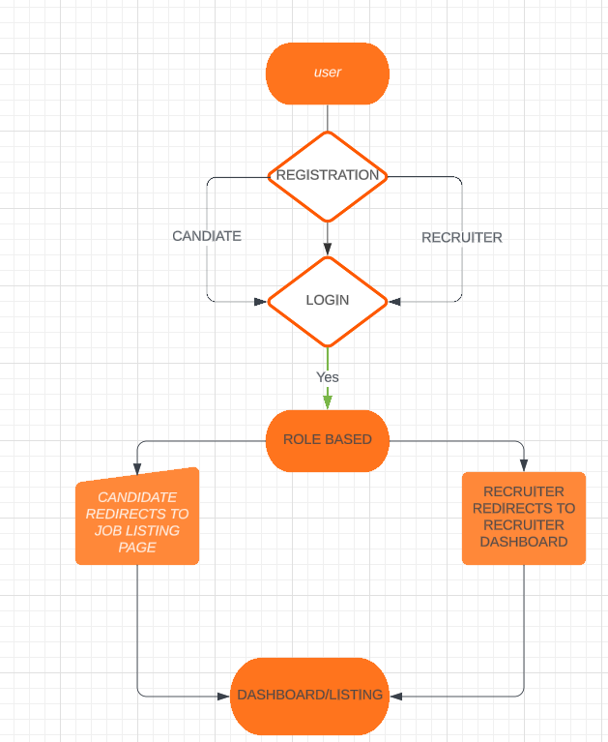

Roles:

* Candidate: Job seekers who can view job listings, apply for jobs, and manage their profiles.
* Recruiter: Employers or recruiters who can post job listings, view applications, and manage company details.

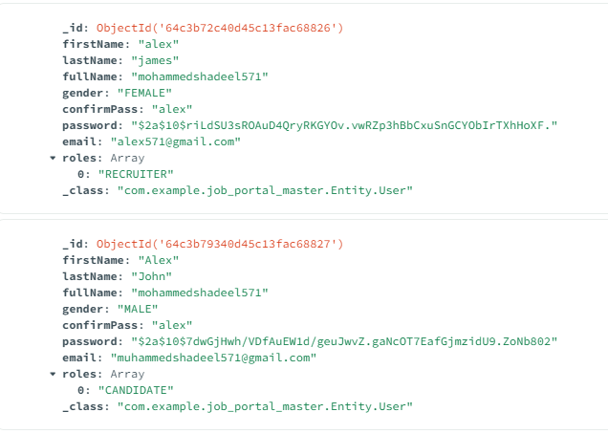

# Authentication and Authorization:

* Implement user authentication using Spring Security to handle login functionality securely.
* Configure role-based access using Spring Security roles, such as "ROLE_CANDIDATE" and "ROLE_RECRUITER."

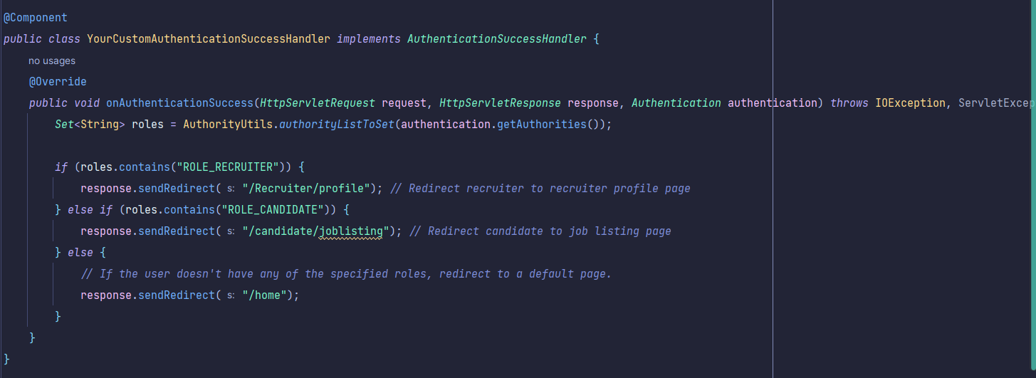

## User Registration:

* Allow users to sign up with their email and password to create a new account.
* Provide an option for users to select their role during registration.

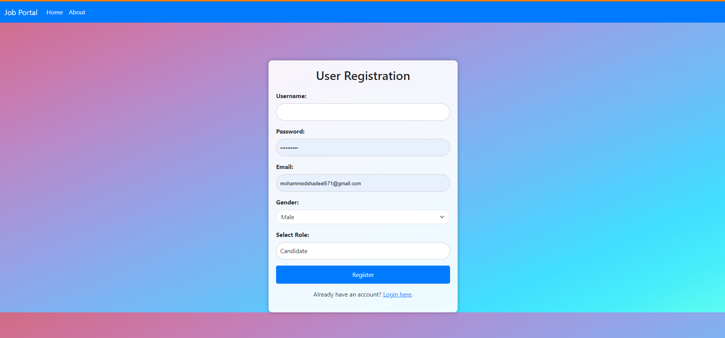

## Login:

* Display a login page where users can enter their credentials.
* After successful authentication, redirect users to their respective dashboards based on their roles.

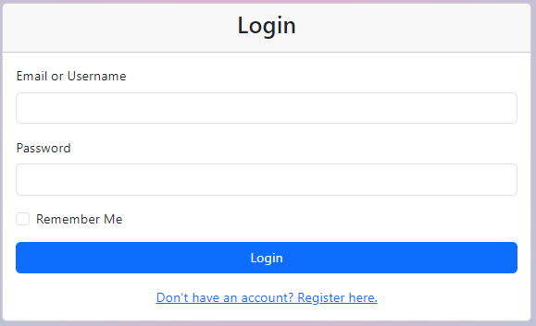

# Dashboard Views:

## Candidate Dashboard:

* + Show a list of recommended job listings based on candidate preferences.
  + Display recent applications and the status of each application.

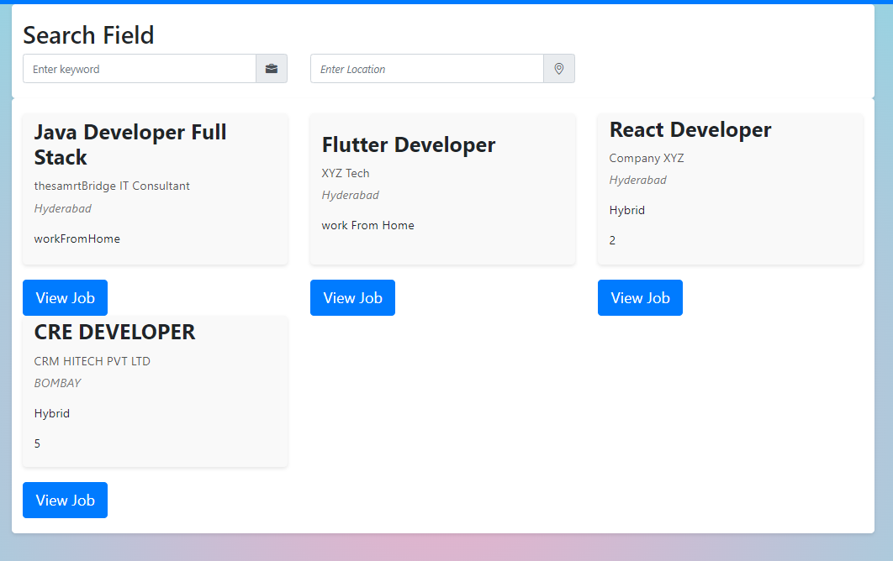

## Recruiter Dashboard:

* + Provide a form to post new job listings with relevant details.
  + Show a list of applications received for each job listing.
  + Allow recruiters to manage company details and job listings.

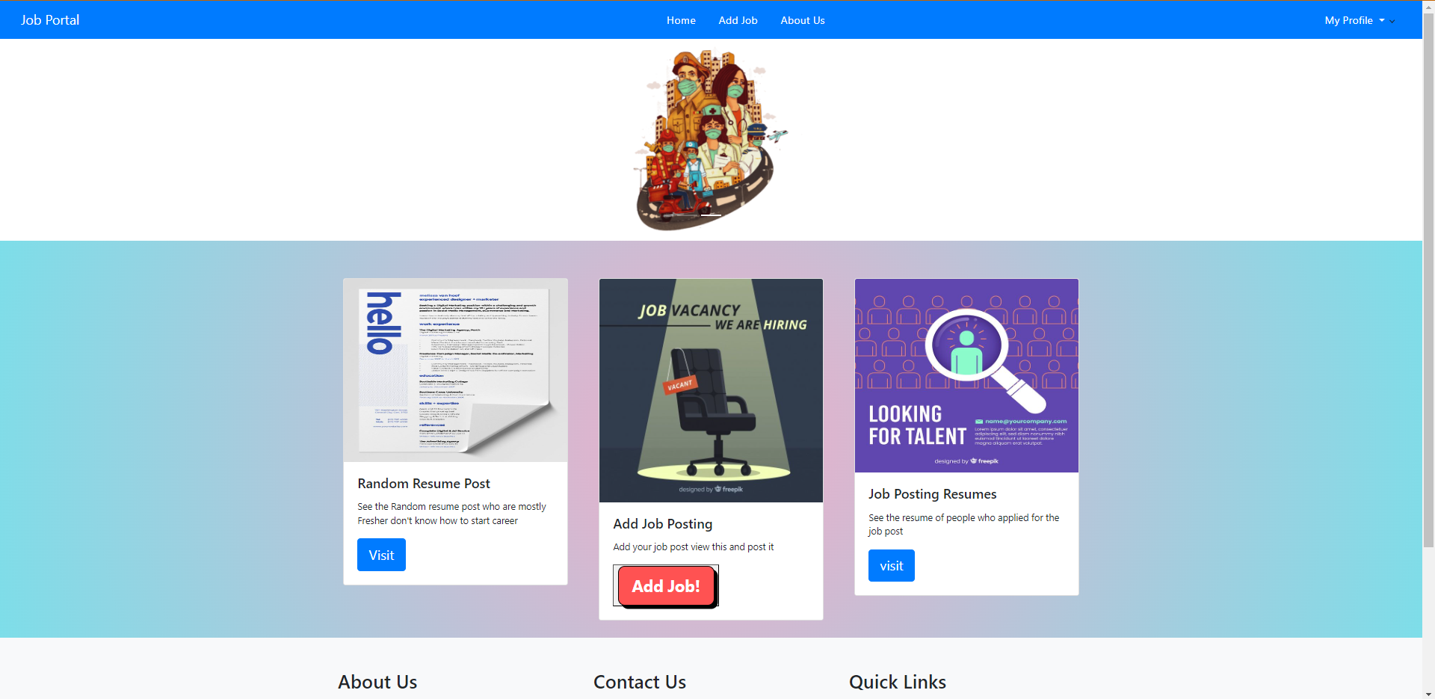

# Access Control:

* Use Spring Security annotations to restrict access to certain endpoints based on user roles.
* Candidates should only access candidate-specific features, and recruiters should access recruiter-specific features.
* Define User Roles: In your application, define different user roles such as "ROLE_CANDIDATE" and "ROLE_RECRUITER." These roles will be used to differentiate between candidates and recruiters and restrict access to specific features.
* Configure Spring Security: Configure Spring Security in your application to enable role-based access control. This can be done using the @EnableWebSecurity annotation and creating a custom implementation of WebSecurityConfigurerAdapter.
* Implement UserDetails and UserDetailsService: Create a custom UserDetails class to represent the user information, including their roles. Implement a UserDetailsService to load user details from your data source based on their username (or email).
* Secure Endpoints with Role-based Access: Use Spring Security annotations to secure your endpoints based on user roles. For example:
* Use @Secured("ROLE_CANDIDATE") on endpoints that should only be accessible to candidates.
* Use @Secured("ROLE_RECRUITER") on endpoints that should only be accessible to recruiters.
* Handle Access Denied: In case a user with insufficient privileges attempts to access a restricted endpoint, handle the access denied scenario gracefully. This can be done using custom access denied handlers or by providing a custom access denied page.

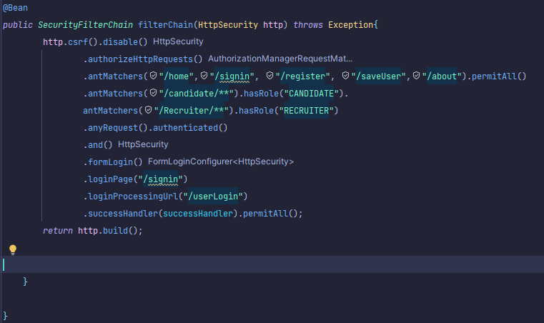

# FILE HANDLING

**File Upload (Candidate):**

1. Log in as a candidate and access the Job listing.
2. Click on "Post your Resume" in the search menu.
3. Upload a resume file by clicking on the "Choose File" button in the resume section.
4. Select the desired resume file from your local storage and click "Upload" to save it.
5. The resume will be uploaded and associated with your candidate profile.

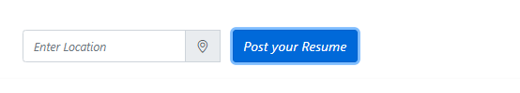

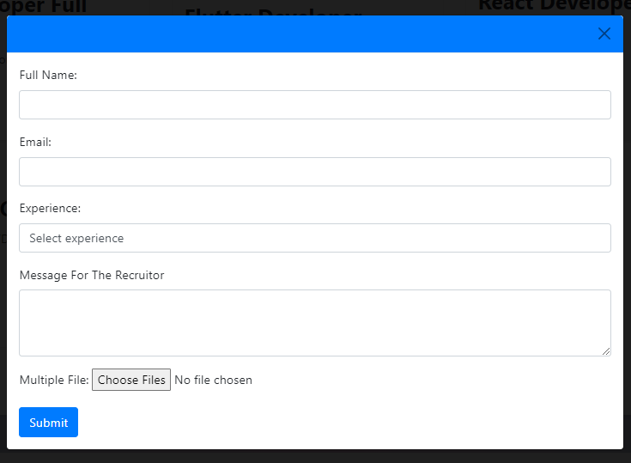

This is the output of file upload in MongoDB Compass

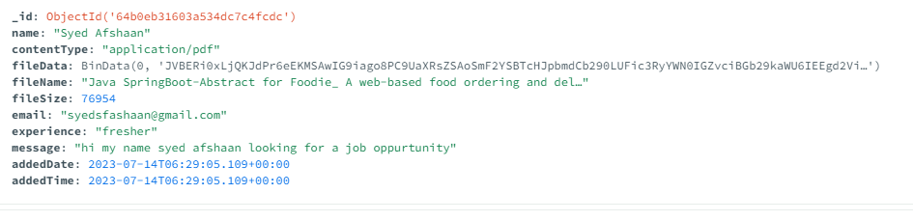

## File Download (Company/Recruiter):

1. Log in as a company/recruiter and access the dashboard.
2. Click on "View Applicants" in the navigation menu to see the list of candidates who applied for jobs.
3. Find the candidate whose resume you want to download and click on their profile.
4. Look for the "Download Resume" button or link within the candidate's profile information.
5. Click on the "Download Resume" button, and the candidate's resume file will be downloaded to your device.



this is the output of downloading file which content type is PDF

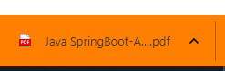

# USING BCRYPTPASSWORD ENCODING TO SECURE PASSWORD

BCryptPassword is a password hashing algorithm used for secure password storage in the project. It is a widely used and recommended approach for storing passwords in a secure manner, protecting them from being easily exposed in case of a data breach.

In the project, BCryptPassword is utilized to securely store user passwords when they register or update their credentials. It works by taking the user's plain-text password, generating a salt (random data), and then hashing the combination of the password and salt using the BCrypt algorithm. The resulting hash is then stored in the database.

When a user attempts to log in, the entered password is hashed using the same BCrypt algorithm and compared with the stored hash in the database. If they match, the user is granted access; otherwise, access is denied.

The use of BCryptPassword enhances the security of the application by ensuring that user passwords are not stored in plain text, making it much harder for attackers to obtain the original passwords even if they gain access to the database.

Overall, BCryptPassword is a crucial component of the project's security infrastructure, helping to protect user credentials and maintain the confidentiality of sensitive information.

## How to use it:

* First Register your details as profile to login
* Now, login with your credentials you provided in Registration
* You will be prompt to that page which your role is selected as

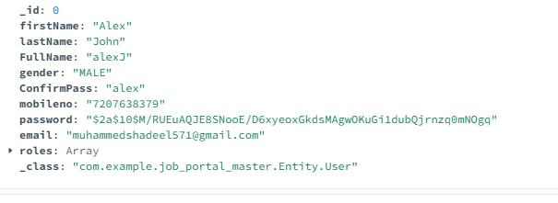

It uses 11-bit encryption algorithm to encode the password so the password cannot be decode by anyone.

# TESTING EXECUTION

Installation and Setup Instructions**:**

* Download the project from GIthub Link provided below the documentation
* Extract it and place it under an individual folder so you can have quick access to it.
* Open the IDE which you wanted to Use, In my case I’m using Intellij Idea 2023.1 Community Edition.
* Simple Drag and Drop the folder to IDE and rest IDE will take care to setup the Environment for the project
* **Requirement:**
* **OS:** Windows 8 to 11 **/Linux**
* **IDE**: IntelliJ Idea
* **Database**: MongoDB compass
* **Email Service**: Google Mail SMTP

## Running the Application Locally:

* You can run the application locally too if you want here is how you can do it.
* Download and install MongoDB from this link: <https://www.mongodb.com/try/download/compass>
* And Download Drivers too without it you cannot connect to MongoDB here is the instruction follow and install

<https://www.mongodb.com/docs/compass/master/install/>

* It is not easy sometimes to connect database to IntelliJ so you will need Configuration file so IDE can understand the database connection you can do it through by application.properties and having individual Configuration file in project which is already there for you
* Change application.properties if you are using MongoDB locally

Here is the example:

* Now you are ready to go with database connection
* If you cannot connect or doesn’t get connection use test connection in MongoDB to see if url is working or not
* If you have work with MySQL this is different from it.

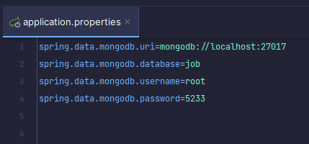

# Configuration and Environment Setup:

* The Dependencies are already in the project so don’t need initiate the project with Spring.io
* If you want these dependencies you needed for project
* **DevTools**: fast application restarts, LiveReload, and configurations for enhanced development experience.
* **Lombok** annotation library which helps to reduce boilerplate code.
* **Thymeleaf** modern server-side Java template engine for both web and standalone environments. Allows HTML to be correctly displayed in browsers and as static prototypes.
* **Spring Data MongoDB** data in flexible, JSON-like documents, meaning fields can vary from document to document and data structure can be changed over time.
* **Spring Security** customizable authentication and access-control framework for Spring applications.
* **Spring Web**, including RESTful, applications using Spring MVC. Uses Apache Tomcat as the default embedded container.
* **Java Mail Sender I/O** Send email using Java Mail and Spring Framework's JavaMailSender.

# Configuration of SMTP(Simple Mail Transfer Protocol)

* For sending email you need a provider there are two types of main SMTP providers mostly people use 1. Gmail SMTP and 2. Amazon SMTP
* If you use Gmail SMTP you need to setup configuration in application.properties
* For you it already in project and if you want to use different SMTP follow the instruction on there official site
* this is what configuration looks like
* the arrow shows the credential for the google mail app password protect so your own password couldn’t be expose to others
* follow this link of instruction to have your own password provided by google <https://support.google.com/mail/answer/185833?hl=en>
* that’s it you are ready to use email in spring boot

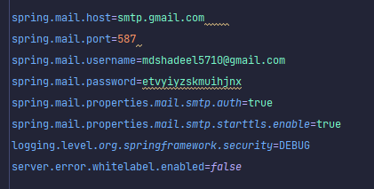

# Configuration of File Upload and Download

* To upload and download a file you will need MongoRepository as your repository to have methods which performs CRUD operations.
* Your REST api should be performed by MogoRepository which is extends to Repository we are using in project.
* Remember one thing that MongoRepository Uses only **16MB** of file upload limit which is sufficient for any PDF format
* The content type for PDF is “application/pdf” every file type has different content type this is for pdf format
* To setup FIile Upload and Download you need specify application that how much maximum and minimum size of file it should have you can do that in **application.properties.**
* here is the properties for file upload and download
* In this you have configured the file maximum and minimum size to upload
* This is just an example you will only need **16MB** file size pdf

Now you are all set to execute the project open the project and execute it by clicking on Run Button.

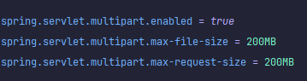

# USER REGISTRATION

* Firstly <http://localhost:8080/register> paste this on you url bar which is search bar then you will see a registration interaction like this
* It is a role based project after filling up necessary data in form you have to select role for your self if you want Job select “candidate” and if you want to seek a candidate for job fill up you can choose “recruiter”
* Based on what you select the profile would be saved in database after registration it will redirect you to login page use those credentials to login page and write down your credentials in note or save it in browser for it to login
* After Successfully login into your desired role you can do operations which are assigned to you only based on role.

## CANDIDATE ROLE BASE LOGIN

* After login into your default page you will see job listing where you can apply jobs and search job based on “Skills” and “location”
* You can also post your resume to recruiter which will be send to recruiter random resume dashboard
* Here is how it looks when you login in with candidate role

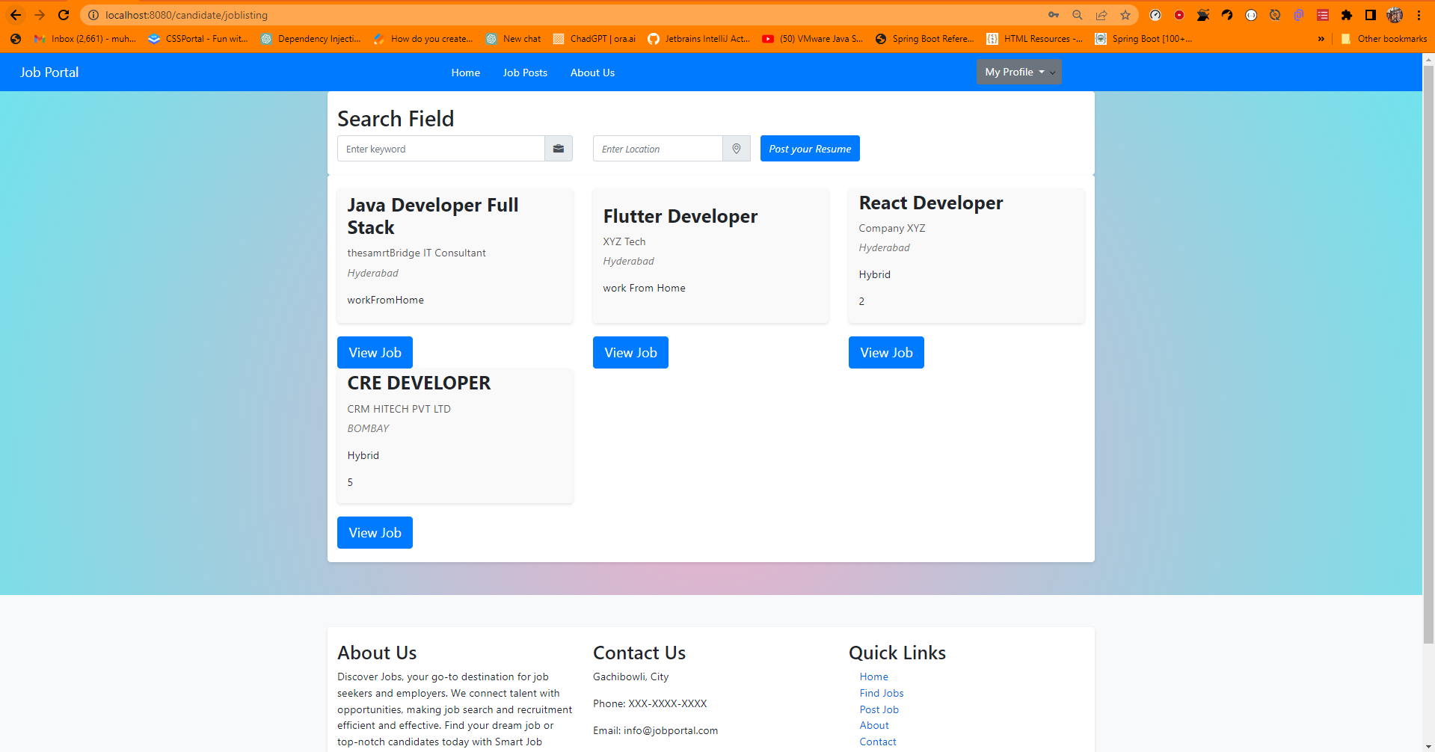

* click on view job button to view job details where you can see what job requirement is

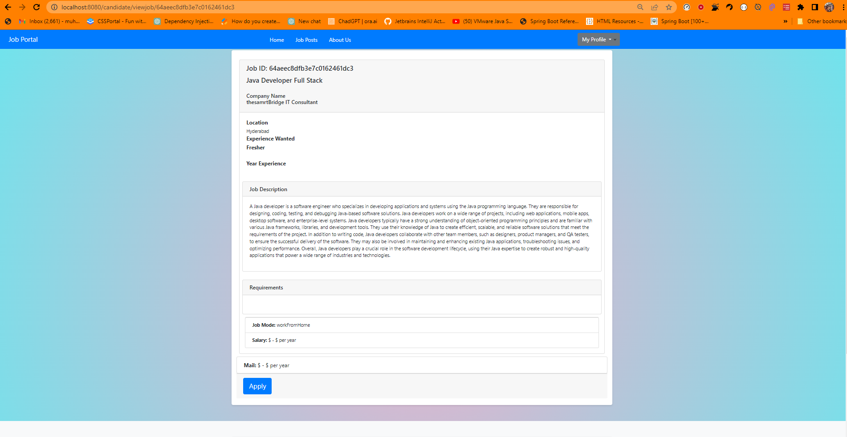

* click on apply button to apply for job a form would be pop-up fill the form

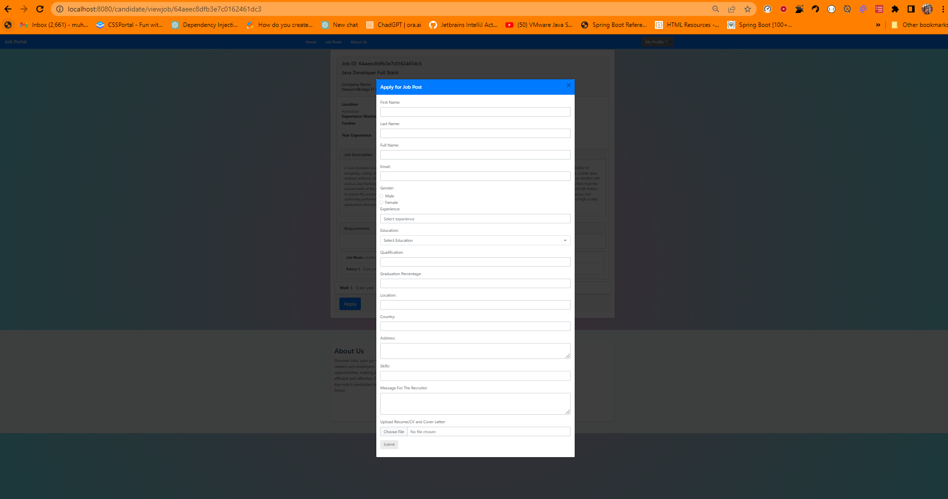

* in this picture you cannot see the form as they are farious input in it so just fill up the form and upload your resume and remember that file upload max size is only **16MB** after uploading the file you will be redirect to job listing

# you can also view your applied jobs from your dashboard

* To view applied jobs in dashboard click my profile on the navbar and click on “My Profile” so you can be redirect to dashboard page

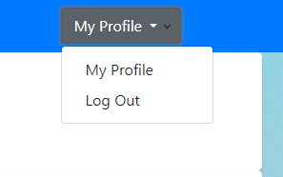

* After clicking on “My Profile” page you will see applied job page

`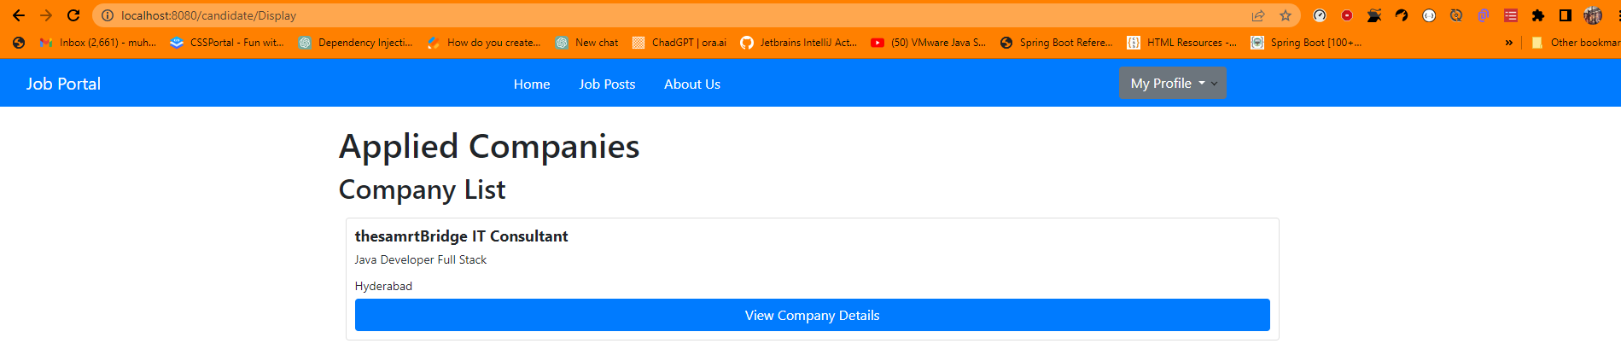

## RECRUITER ROLE BASE LOGIN

* For recruiter role base login it is same as candidate registration but you will have to select Role as “Recruiter” in registration page
* after registration you will redirect to login same as registration here how you can see if login was successful

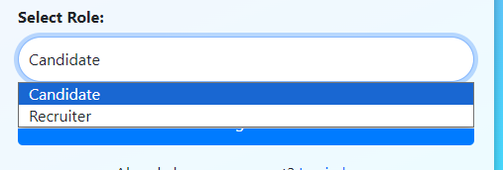

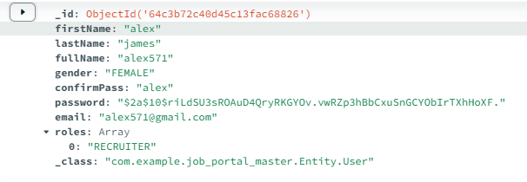

* login into as recruiter you will be forwarded to recuiter dashboard

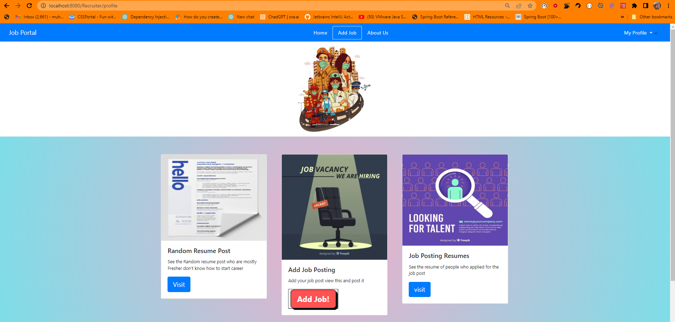

* you have three options in dashboard as you can see
* the first one is random resume which are post randomly by candidate you can send email to candidate and download there resume.

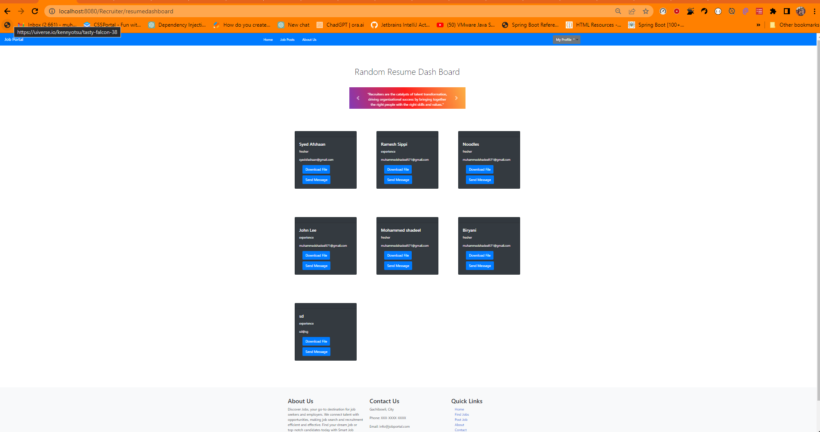

* the second one is for posting a job when you click on that button a form will pop up fill up the form by populating it. It will save the form details in database so that information can be forwarded to candidate job listing where he can apply for job

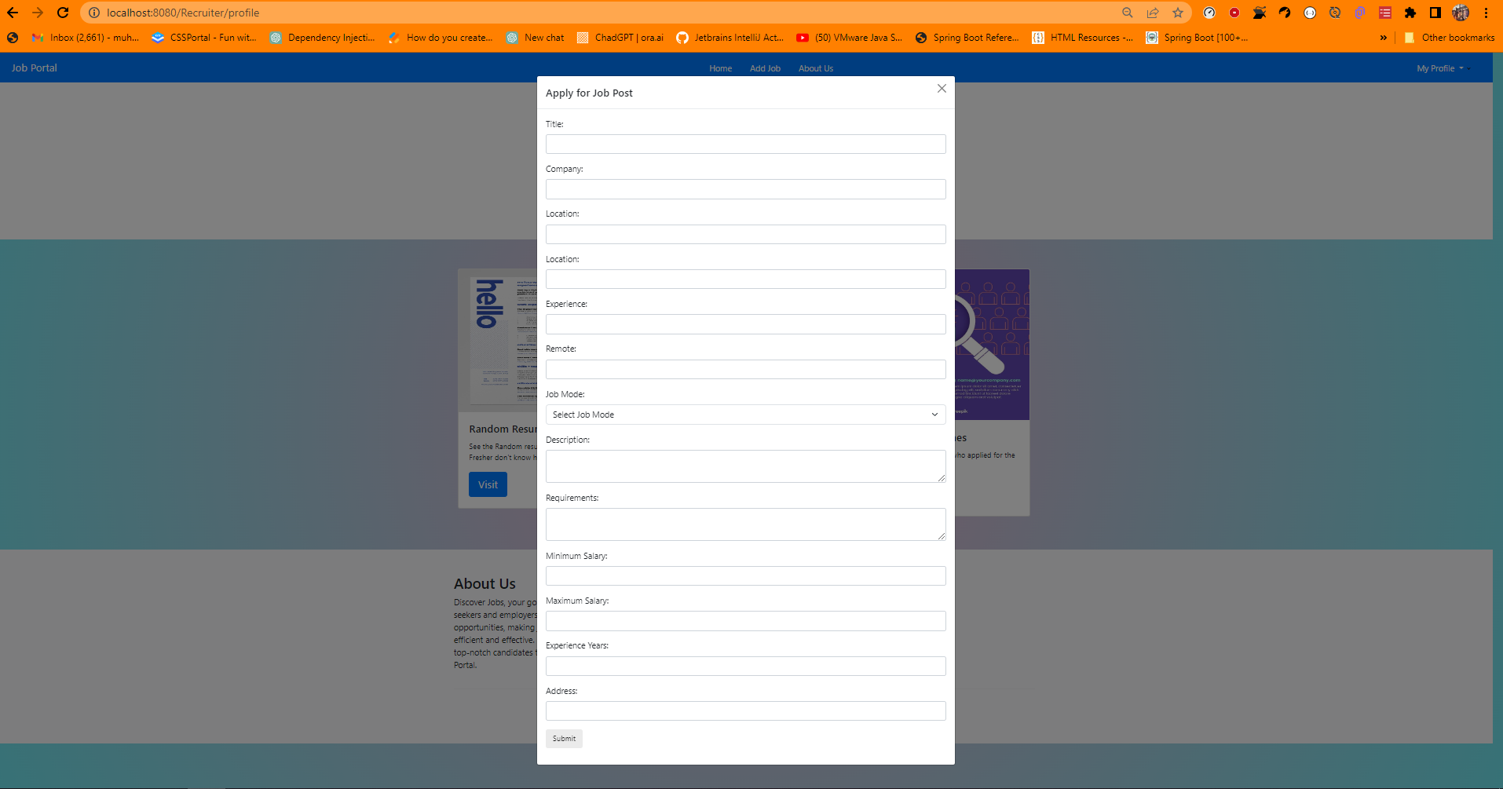

* the third one is for to view profiles of candidates who applied for jobs via job post from job listing which they applied for

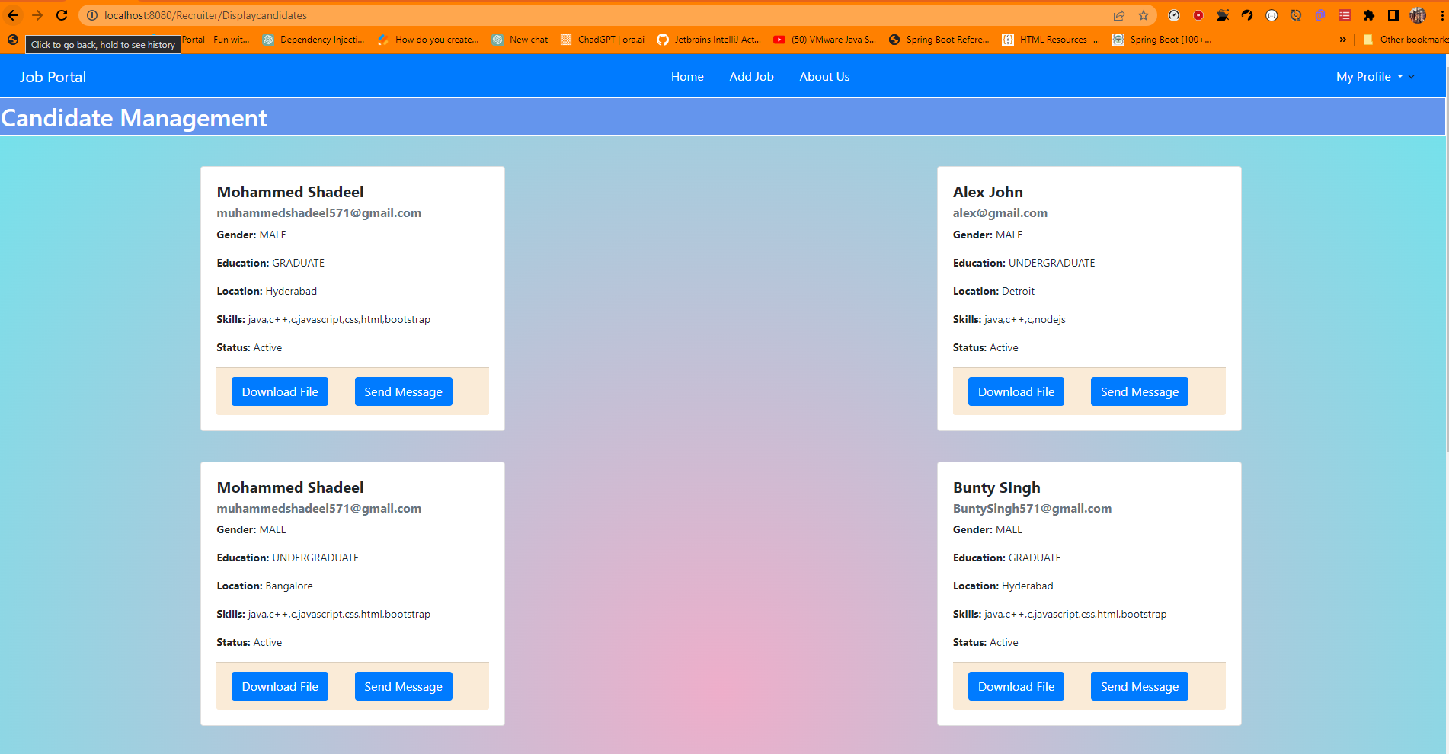

* you can download and send email to the candidate to tell him if he is selected or not

# A RECRUITER CAN ALSO EXPLORE CANDIDATES BASED ON THERE PROFILE IT HAS CANDIDATE LISTING PAGE TOO

* just click on view candidate tab on navbar to view candidate listing of different profile and search operations

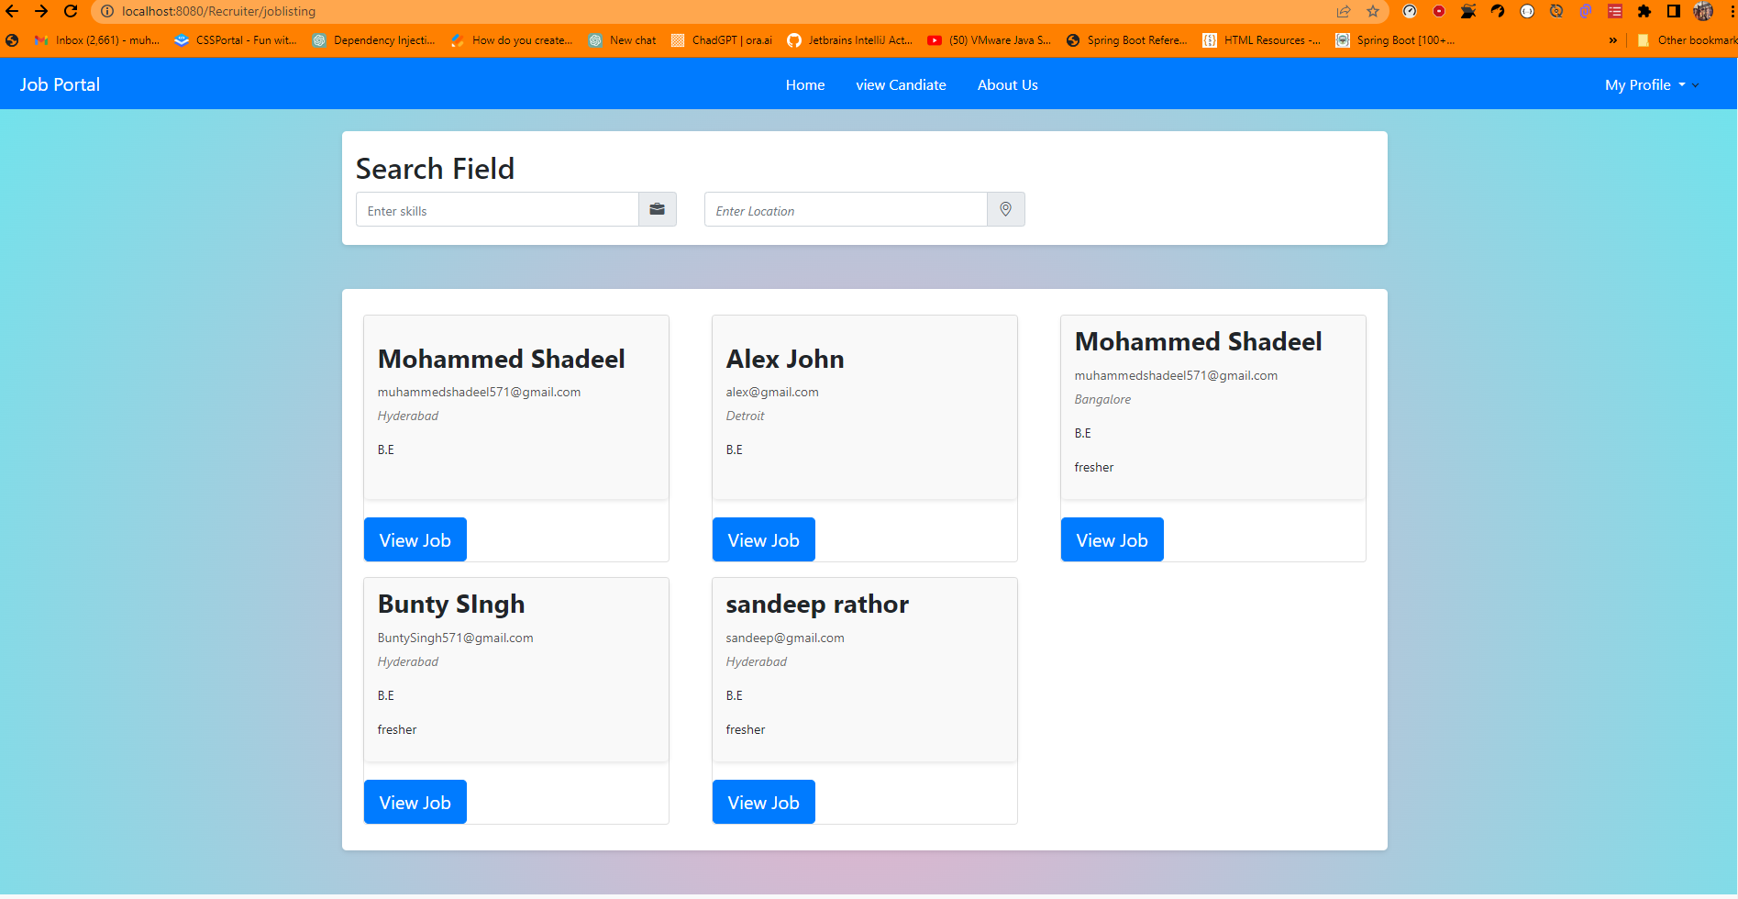

* you can also search base on skills and location of the candidate click on any search field and type the skills you want as a candidate

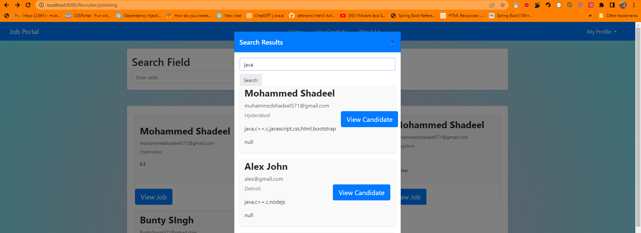

* same as location you can also search candidate base on location too just type location that you want

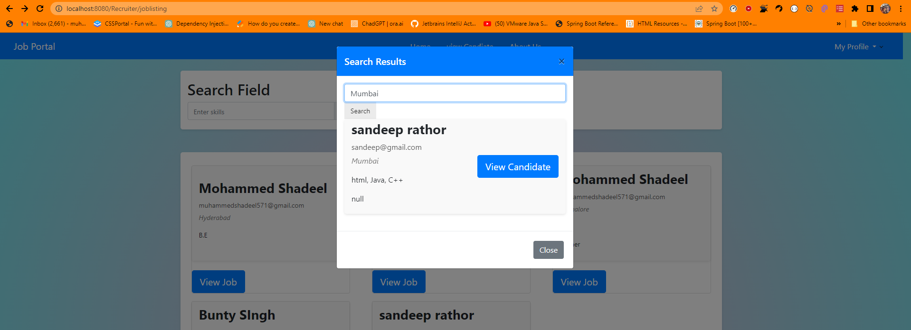

* there are three different type of candidate selection view candidate listing, via skills and location it depends on recruiter choice
* if recruiter wants he/she can view that candidate just simply click on view job button

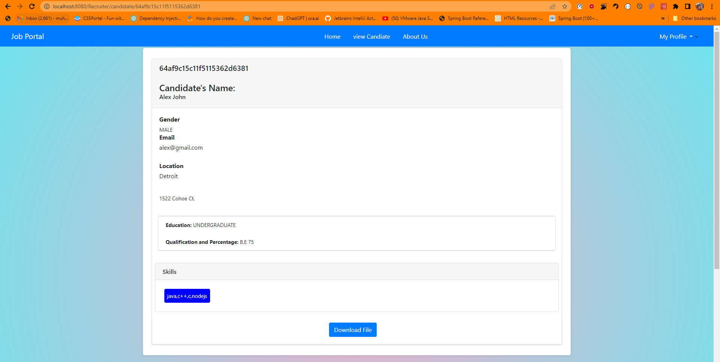

* Download the candidate profile and see there portfolio and if you want to contact the candidate you can visit your dashboard and view candidate by clicking on “My Profile” it will redirect you to recruiter dashboard
* Click on Job Posting Resume to view candidates and then it will redirect you to candidates download or send message to candidate as you want

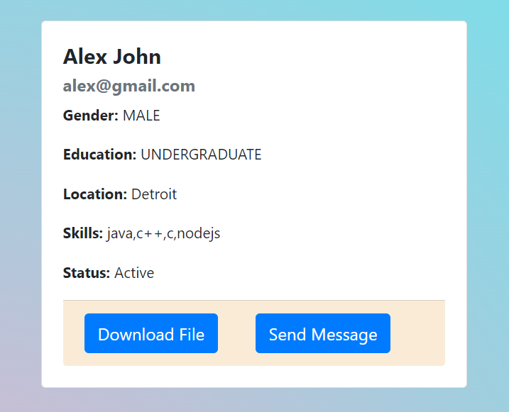

* Recruiter can send a message to candidate and that candidate can know if he/she is shortlisted or not

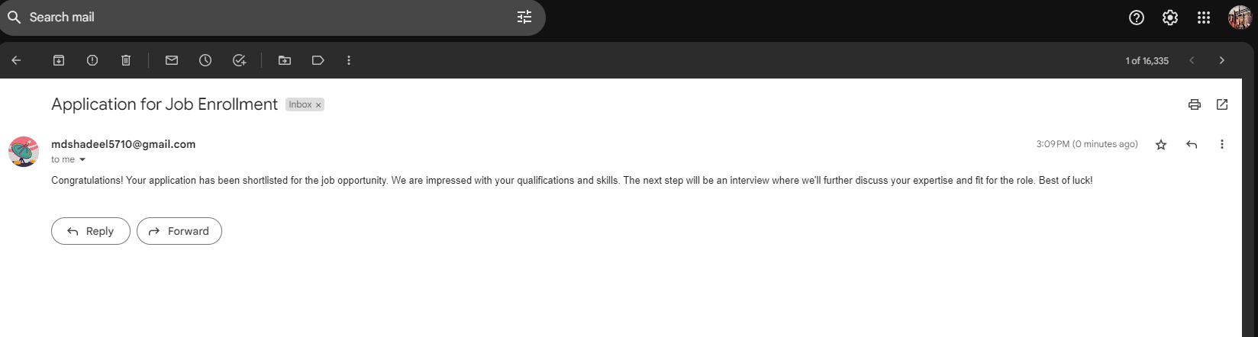

This is it all the operations have been showed in this documentation there will error handling section after if you get any errors I will tell them how to solve it

# Error Solving Section

* If you can not connect to database there is a configuration file in MongoDB official page read that and check if the drivers are installed or to check that
* Open your command prompt, and type the following command: `mongod –version`. It will show the MongoDB version installed on your machine.
* You will see like this on the command prompt with version mention on the CLI

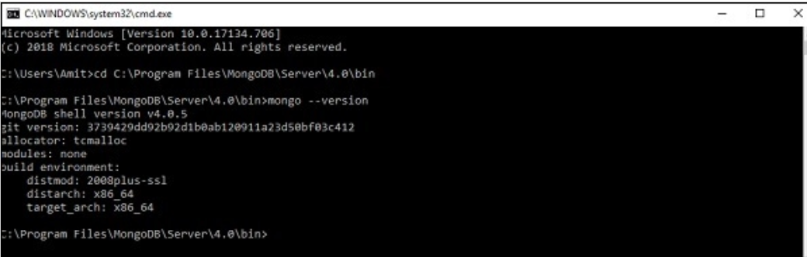

* For authentication and authorization we have use spring security 6 where most of the things are deprecated to encourage using compound methods read this documentation to know it

[**https://docs.spring.io/spring-security/reference/migration/index.html**](https://docs.spring.io/spring-security/reference/migration/index.html)

* mainly error comes from spring security so read the reference carefully

**Project Github link :- https://github.com/moxhadeel571/Job_Portal_Master.git**